Minutes of the meeting 7th May 2026 Ridge Village Hall at 7pm
Present: Cllr Ralph Bania (Chair) Cllr Cathy MacCaffrey, Cllr Mark Hedison, Cllr neil Johnson. Natalie Curran (Clerk) Wendy Martin (Assistant Clerk)
Members of the public – approx. 8

Minutes Ref 26/27
- The Chairperson of the meeting welcomed everyone and thanked them for coming.
- Apologies for absence were received and accepted from Cllr Chris Myers who was at another meeting.
- There were no declarations of Councillor interests pertaining to agenda items.
- The last meeting were approved and the Chairperson signed them.
- Finance:
  - It was noted that the final bill for the by-election that was forced by petition has now been confirmed at £7,914.76 and has been paid to Hertsmere Borough Council.
  - It was noted that the full accounts for the Financial Year ending March 2026 are now complete and have been sent to our internal auditor Brayan & Spencer Associates for checking. See appendix 1 attached for summary.
  - See agenda item 7

Planning:
The following planning applications were discussed:

- 26/0500/FUL Rabley Willow, Packhorse Lane, Ridge. Demolition of existing dwelling and 2x outbuildings, and construction of new two storey dwelling and detached single storey garage with pitched roof, 3x rooflights to each side, and accommodation at roof level, and associated landscaping works
To note background: last year a planning application was considered by Shenley Parish Council for this same property. Hertsmere have now allocated it to SM&RPC but the Clerk has contacted Shenley PC and Hertsmere to clarify. The previous application was rejected and the Clerk has requested more information as the new plans are entirely different but appear to be semi industrial in style with a zinc roof. The building is not listed but sits adjacent to Rabley Park which is.

- Housing consultation (pre app) for up to 195 homes -`Site of previous Block W NIBSC and UCL Car Park, Blanche Lane, Ridge. An update was received from the Chair and Clerk who had attended a meeting with Reef Origin. See appendix 2 for site map. This land has already been determined as a brown field size as it contains an existing building that will be demolished. Reef Origin will not commence and works unless the adjacent site at Stilegate Stud is fully compliant with the current Enforcement being undertaken.

- Planning Appeal -

It was agreed that the following proposed wording was submitted in response to the Planning Inspectors appeal hearing against the refusal of retrospective planning permission by Hertsmere Borough Council at:
1 Baytree Cottages,Crossoaks Lane,Ridge – a 17th Century Grade II list cottage

Details A glass roof on the side conservatory was replaced with modern roof tiles and a roof light was installed without prior listed building consent. Hertsmere refused the retrospective permission on the basis that the modern materials used were not in keeping with the Grade II listed status.

Proposed response:

The 20thCentury lean-to addition to the cottage, that is the subject of this appeal, is of limited historic interest and therefore the Parish Council had no fundamental objection to a material change from the unsafe glass previously in place.
However, the roof tiles used were not appropriate for a 17th century Grade II listed building in the Conservation Area; being different in size and colour from the traditional clay tiles on the main roof.
Whilst the tiles installed have now weathered somewhat, they remain unsuitable for a listed property.
Additionally, the rooflight window installed is not flush and protrudes above the roof slope. The Parish Council is of the opinion that this should be remediated to a Conservation Roof Window that sits flush (https://www.velux.co.uk/products/roof-windows/conservation-roof-windows) rather than the standard window used.

- Community
The issues suffered by residents due to the improper use of the UCL Bus Turnaround in Blanche Lane was discussed and the Clerk undertook to speak again to Cllr Nic Oakley.

The Clerk undertook to contact St Giles School to suggest that the Community Police attend at school pick up to advise on bad parking.

The Cllr Bania thanked all attending and the date of the next meeting was confirmed as 4th June at South Mimms

____________________________________________________________________

Appendix 1)
Bank Account Summaries 2025/26 Financial Year
HALL |  |  | Income | Expenditure |  | Closing Balance
Hall Opening Balance on Account |  |  | £3,307.88
Income from Village Hall Rent |  |  | £14,056.71
Cost of running hall |  |  |  | £9,026.81
Net Operting Profit of Hall 2025/26 |  |  |  | £5,029.90
Hall Closing Balance Checked to NatWest |  |  |  | £8,337.78 |  | £8,337.78
CIL Account |  |  | Income | Transferred Out |  | Closing Balance
Interest Received |  |  | £106.11
CIL Received 2025/26 |  |  | £0.00
Transfer to Current Account |  |  |  | £4,955.50
CIL A/C Opening Balance |  |  | £11,048.20
Net Transactions (interest less transfers to current a/c) |  |  |  | -£4,849.39
CIL A/C Closing Balance |  |  |  | £6,198.81 |  | £6,198.81
MAIN ACCOUNT
Current Account |  |  | Income | Expenditure |  | Closing Balance
Current Account Opening |  |  | £3,710.84
Precept |  |  | £28,320.00
All other income including refunds from Borough Council and HMRC |  |  | £13,007.13
Staff Expenditure |  |  |  | £22,329.59
All other outgoings |  |  |  | £22,086.70 | *
Current Account Closing Balance |  |  |  | £621.68 |  | £621.68
Total Cash Closing Balances All Accounts |  |  |  |  |  | £15,158.27
*Includes | Grant to Ridge Village Hall |  |  |  | £3,520.00
 | Hertfordshire Assoc Town and Parish Councils (HAPTC) |  |  |  | £590.00
 | Zurich Insurance |  |  |  | £395.22
 | Litter Picking |  |  |  | £1,200.00
 | Website and Email hosting plus Wifi booster instillations |  |  |  | £925.00
 | Herts Highways Projects |  |  |  | 5,928.00

Appendix 2)
Reef Origin Sites – White block proposed flats on part of NIBSC car park
Red outline houses on block W site

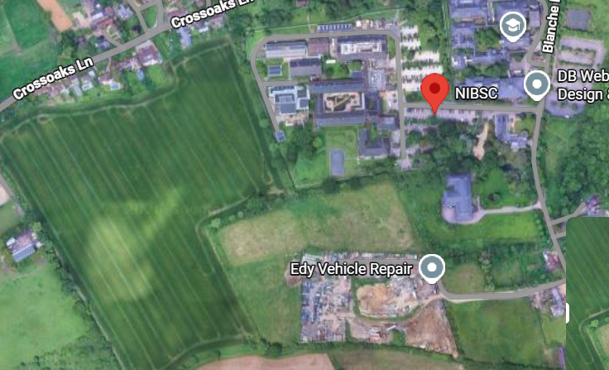
Stilegate

